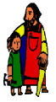
KS2 Geography Knowledge Organiser: Trade and Economics
Year 6

In this unit you will focus on:
- I can explain what the UK trades and how trade works
- I can use maps to show the UK’s trade links with other countries.
- I can explain trade links between El Salvador and the UK
- I can explain the importance of fair trade
- I can explain the global supply chain
- I can explain how trading has changed through history.
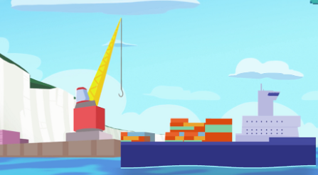

What? (Key Vocabulary)
Trade | Buying and selling goods and services.
Import | Goods or services purchased from one country and brought into the UK.
Export | Goods or services made in the UK and sold to another country.
Fair Trade | A way of buying goods designed to make sure that the producers of these goods in developing countries are paid a fair and stable price for the goods we buy from them.
Globalisation | The spread of trade and ideas worldwide.
Economy | The word used to explain how money is made and spent in a particular area. This could be within a country or across the world.
Where? (Key areas to learn about)
UK exports | These include: scrap iron, whisky, tartan kilts, medicines, aircraft parts, cars, computers, oil and gas.
UK imports | These include: coffee beans, bananas, medicines, aircraft parts, cars, computers, oil and gas.
El Salvador imports to the UK | These include: coffee, cotton, sugar, shrimp, fruit and nuts

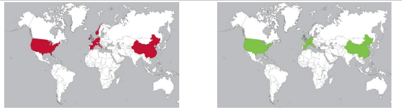
Impact (on us at St Joseph the Worker)
Irlam has always been an important area for Manchester’s historic trade. Situated perfectly on the banks of the River and Canal, Irlam has a rich history of trade and manufacture including Steel Works, Margarine Works, Soap Works, Rope Works etc.
These trades and its proximity to Manchester made it the perfect place to help develop Irlam’s population and popularity.

Key Facts
Fair Trade exists to make sure that people are not exploited. Look out for the fair trade logo when buying things so that you know that people are paid fairly for their work.
Trade has changed a lot throughout history due to developments in transportation but also due to the UK’s changing relationship with other countries.
Globalisation has meant that more and more goods travel around the world before being sold in a shop. Sometimes, part of a product are made in several different countries before being assembled in another one.

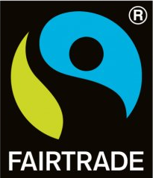
Kahoot Quiz Scores
Pre Assessment | Post Assessment

