Jumble up!
Here is a list of 10 French cities which have been jumbled up. Can you unjumble them? To help you, the first letter of the city has been given a capital letter.

iellL | Lille
ciNe | Nice
tesNna | Nantes
noDji | Dijon
raPsi | Paris
rTuos | Tours
dxuaBore | Bordeaux
siCaal | Calais
esLiomg | Limoges
neuoR | Rouen
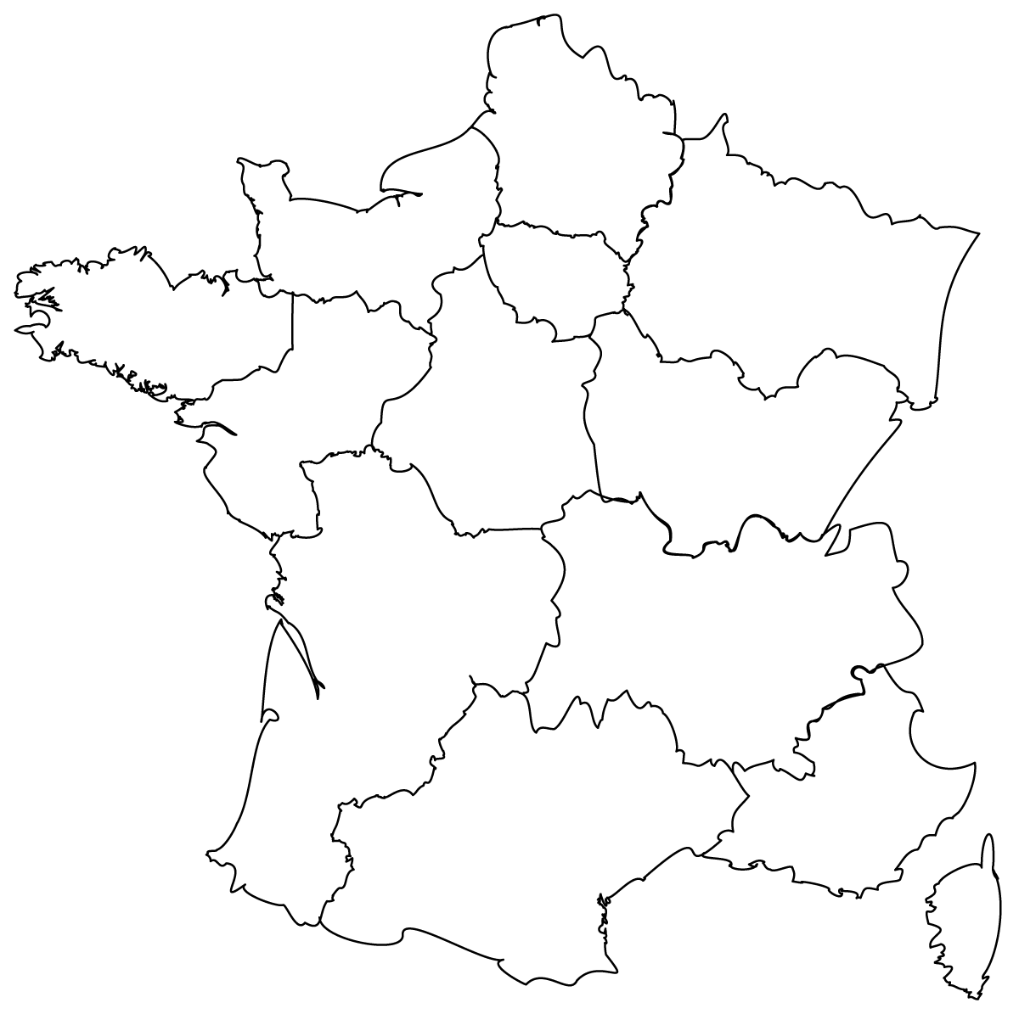
Mark the cities on the map below!
Rouen
Calais
Lille
Bordeaux
Nice
Paris
Dijon
Limoges
Tours
Nantes

